Block 1: Buttons and Toast

The following application demonstrates that a single screen can host multiple buttons. Each button has its own background colour and text. Multiple actions can be triggered when a button is clicked. This application demonstrates 2 actions: changing the visibility of a button and displaying a pop-up message (called a "toast" in Android).
This application is composed of a single screen. The graphical interface proposes 2 buttons to the user: a blue button labelled "The Invisible Man's To Do List" and a pink button labelled "The Pink Panther's To Do List".
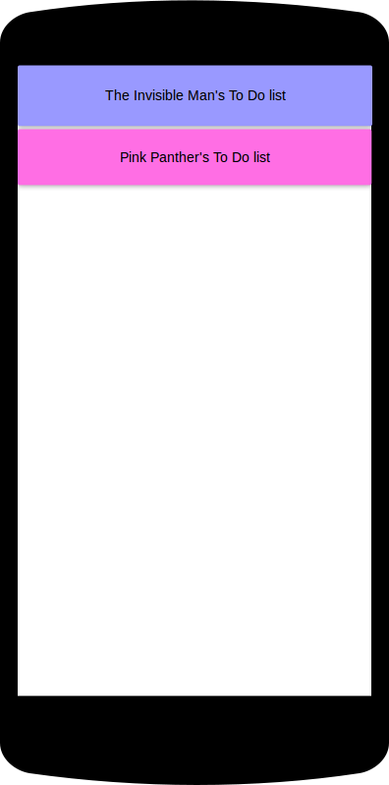
When the first button is clicked, it disappears:
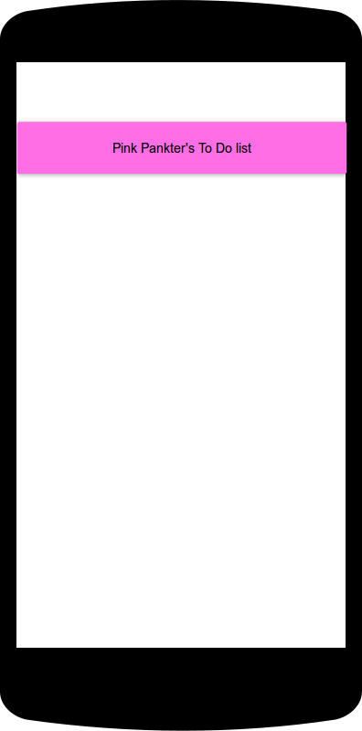
When the second button is clicked a pop-up message reading "to do, to do, to do, to do..." is briefly displayed to the user:
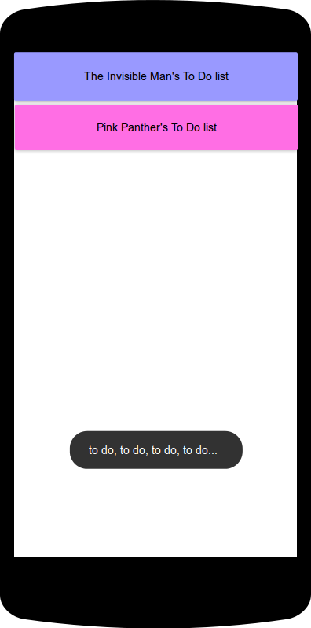
To experiment a bit with this application, you can download:
- the application to try it out on your phone:

Block 2: Clickable List in two Languages

The following application demonstrates the use of a ListView to display items in rows. An action can be triggered by the selection (click) of an item; in this application the action is to display a different pop-up message ("toast") for each item. If the language setting of the phone is set to "French", the mechanics of the application stays the same (a pop-up is displayed when an item is clicked) but it is the French translations of each character strings (items, as well as pop-up messages) that are displayed.
This application is composed of a single screen. The graphical interface features a TextView which prompts the user to pick an animal in the list displayed below. The list contains 4 items (horse, pig, dog and cat).
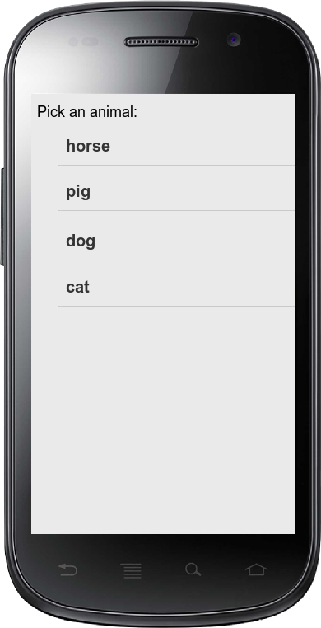
If the user clicks on "pig", a pop-up message confirms the choice:
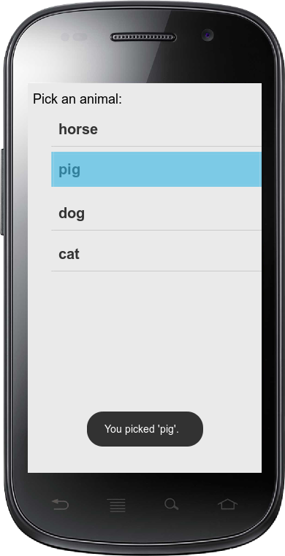
If the user now selects "dog", another pop-up message is displayed:
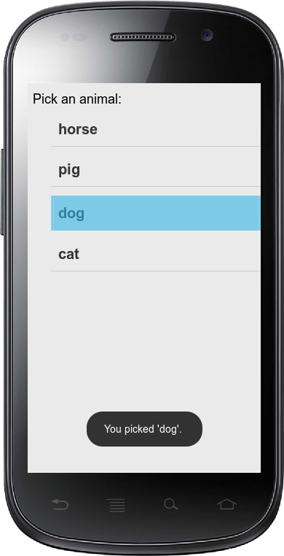
If the phone settings specify French as interface language, the application displays the following:
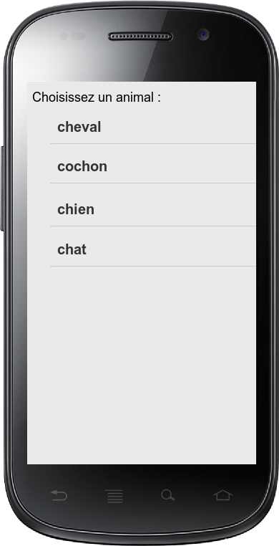
If the user clicks on "chien", the pop-up message is displayed in its translated version:
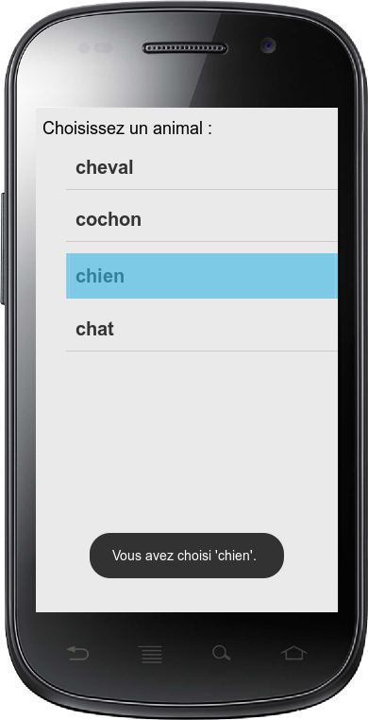
To experiment a bit with this application, you can download:

Block 3: Layouts

This application demonstrates some layouts you can use to organize components of your user interface.
This application is composed of a single screen, divided in 2 rows by an horizontal LinearLayout. The first row is set to occupy 1/3 of the screen and the second row occupies the remaining 2/3 (note that these are not fixed dimensions, rather relative ones which will be kept no matter the size of the screen).
The background colour of the first row is set to a light blue. In this row, a vertical LinearLayout is composed of 2 columns. The first one contains a button labelled "Small" and sized according to this text. In the second column, a button occupies half the horizontal space remaining free after the addition of the Small button and its height matches the height of the row.
The background of the second row is an image (the compass rose from the Cantino's planisphere).
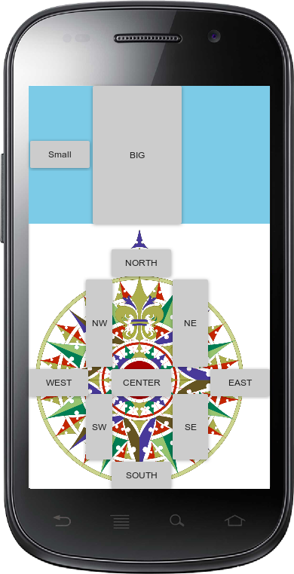
To experiment a bit with this application, you can download:
- the application to try it out on your phone:

Block 4: Playing Sounds (and Using a Switch)

This application plays a music file and demonstrates a few controls over the audio file. It also demonstrates the use of a switch.
This application is composed of a single screen. The first button, labelled "PLAY", starts the audio playing. The second button, labelled "PAUSE", pauses the audio; when PLAY is pressed again, the audio resumes from the point where it was when the PAUSE button was used. Pressing the PLAY button while the audio is already playing does nothing. Pressing the PAUSE button while the audio has not been started or is already paused does nothing.
At the center of the screen, a switch allows the user to choose between 2 modes: if "looping" is on, the audio automatically restarts from the beginning when the end of the file is reached; otherwise (looping is off) the audio stops at the end of the file and the user needs to press PLAY again to hear the music again. The switch can be used at any time during the listening, it is its position at the end of the audio file which matters.
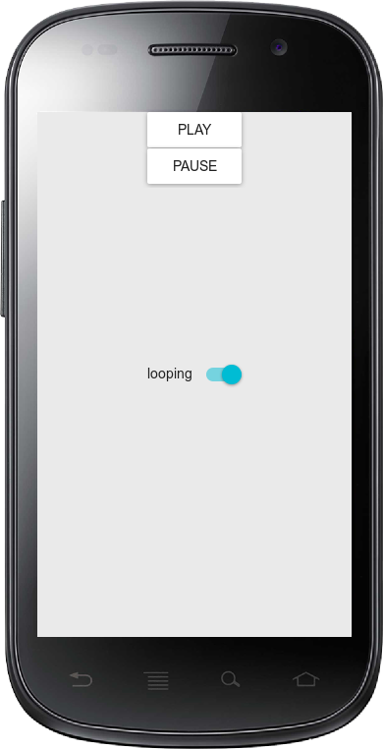
To experiment a bit with this application, you can download:

Block 5: Saving Preferences (and Radio Buttons)

This application demonstrates that user's data can be saved during execution to be used in subsequent executions. It also demonstrates the use of a group of radio buttons.
This application is composed of a single screen. The GUI is composed of a group of 3 radio buttons labelled "Blue", "Magenta" and "Yellow". At the first execution of the application, no radio button is selected and the background is white:
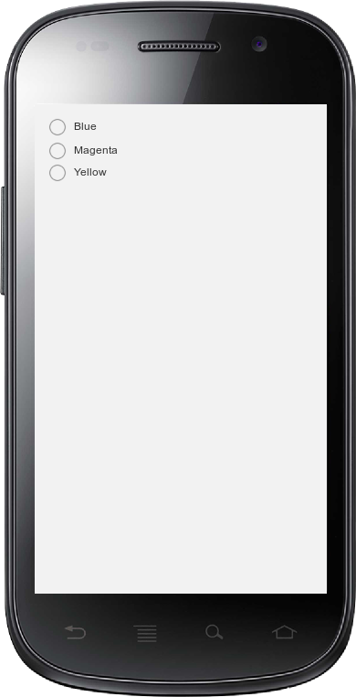
When the user selects the "Blue" radio button, this choice is saved (although that is not visible for the user) and the background turns to blue:
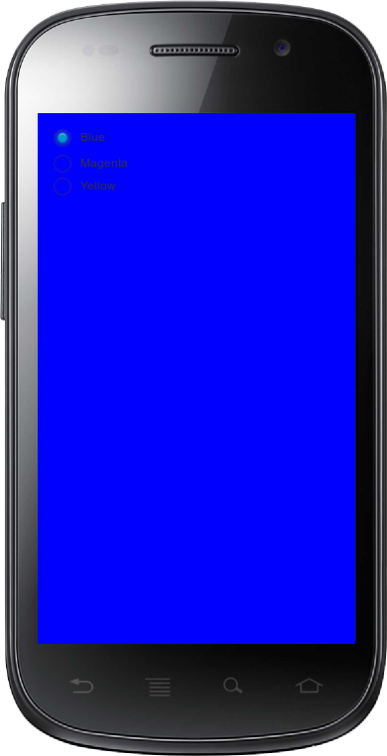
If the user selects the "Blue" button again while in this state, nothing happens. If the user selects the "Yellow" button, this choice replaces the previous one in storage (although that is, again, not visible for the user) and the background turns to yellow:
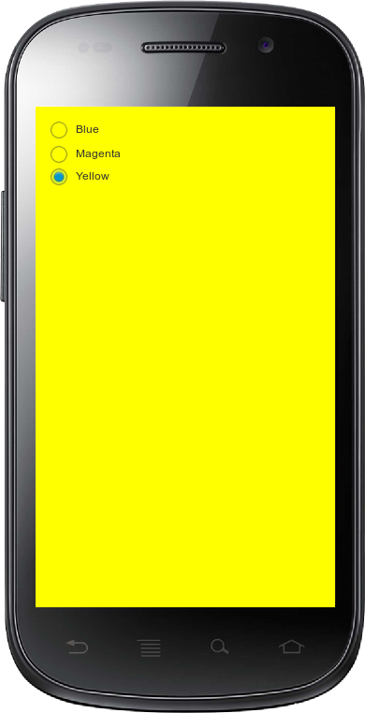
Now when the user quits the application and returns to it after a few seconds/minutes/days, and even if he/she has turned his/her phone off and on again, no radio button is selected but the background is set to the last saved color:
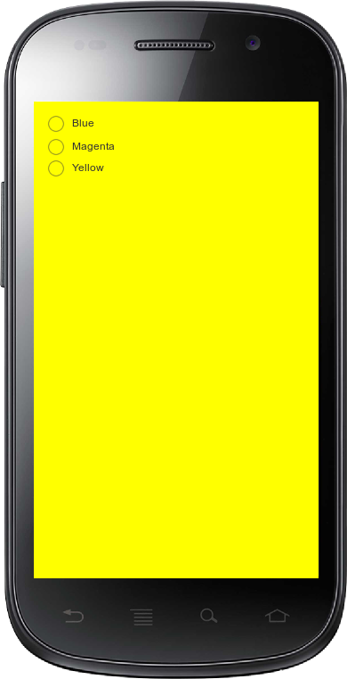
When the user selects the "Magenta" radio button, this choice is saved and the background turns to magenta:
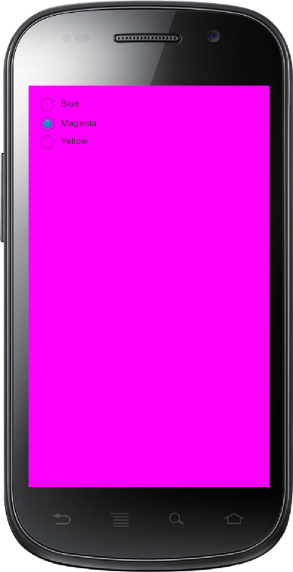
To experiment a bit with this application, you can download:

Block 6: Images (and Slider)

This application demonstrates the display of an image file, and the application of a color filter to the image. It also demonstrates the use of a slider.
This application is composed of a single screen. A small ImageView displays the original image file in the upper left corner and a larger view of the image (width of the screen) occupies the bottom part of the screen. Below the small image a slider is initialized with the cursor half-way:
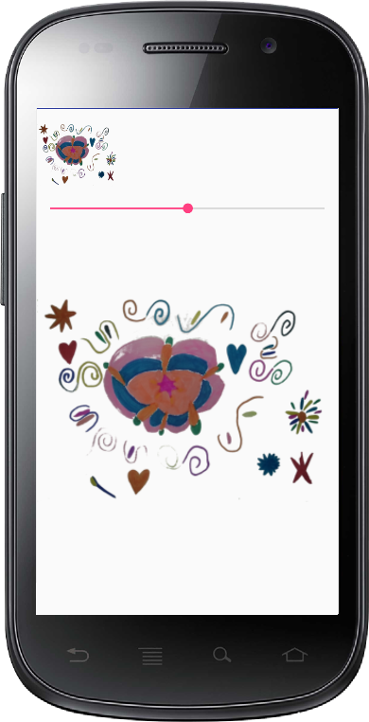
When the user slides the cursor to the right, a green filter is applied to the large image (the more to the right the cursor, the brighter the green):
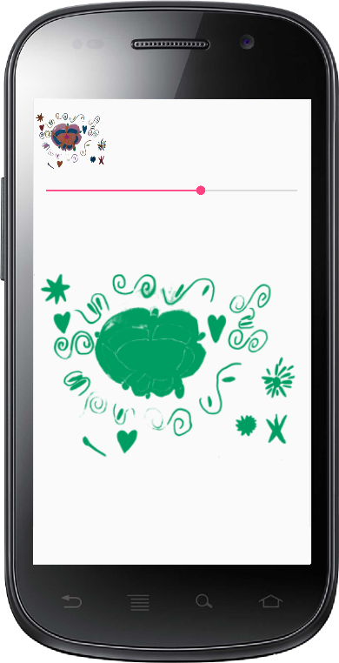
When the user slides the cursor to the left, a blue filter is applied:
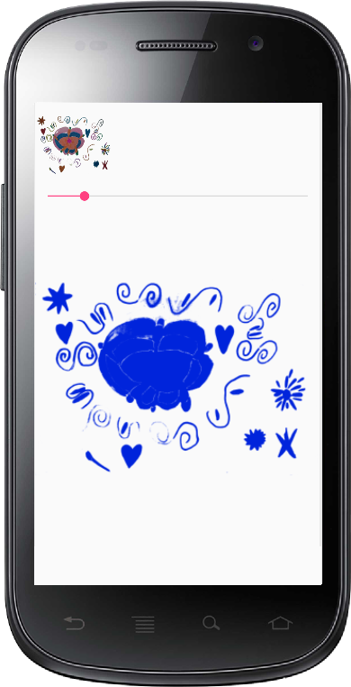
To experiment a bit with this application, you can download:

Block 7: Web Pages

The following application demonstrates the use of a WebView to display web pages from the Internet (if the application was granted permission to access it by the user) or HTML files stored on the device (this is sometime used to easily display texts according to a given style). It also demonstrates the use of a NumberPicker to allow the user to choose among different character strings.
This application is composed of a single screen. The graphical interface proposes a picker which offers 4 choices ("Android", "Supélec", "Coursera" and "checklist text-input field"), a OK button and a web view which, at first, is not visible:
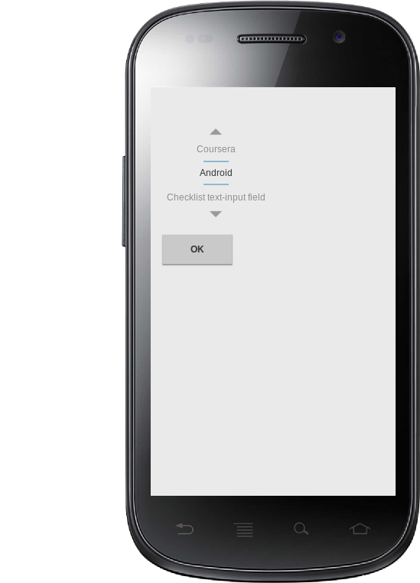
The user selects the content to display using the picker and clicks the "OK" button. Then the web page is loaded in the lower part of the screen:
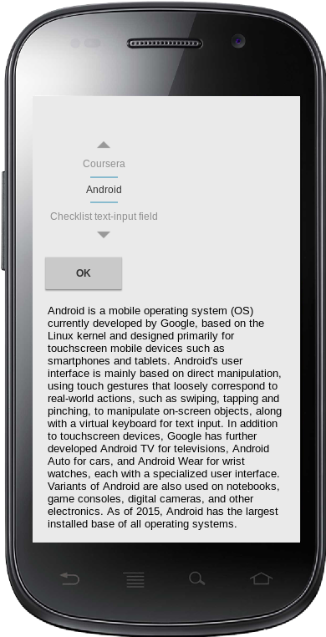
To experiment a bit with this application, you can download:

Block 8: From one activity to the next

The following application demonstrates the succession of two screens, with the second screen displaying information input in the first screen. It also demonstrates the use of a rating bar to allow the user to indicate a rate as a number of stars.
This application is composed of two screens. The first graphical interface proposes a rate bar with 3 stars and a "Enter" button:
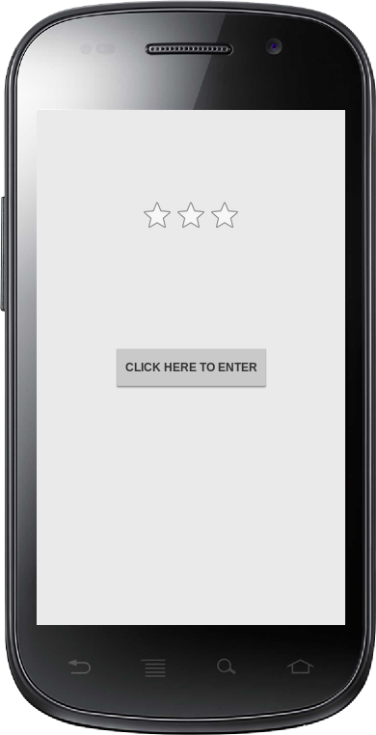
The user selects 0, 1, 2 or 3 stars:
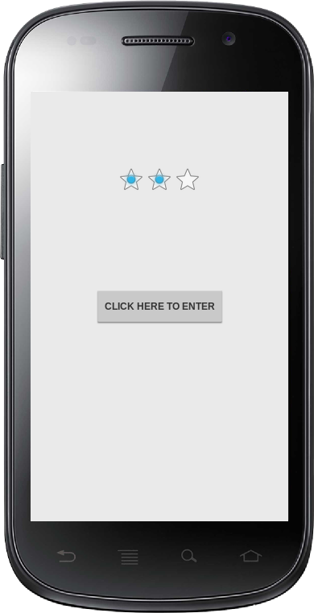
When the user clicks the button, he's taken to a new screen which displays a message indicating the number of selected stars:
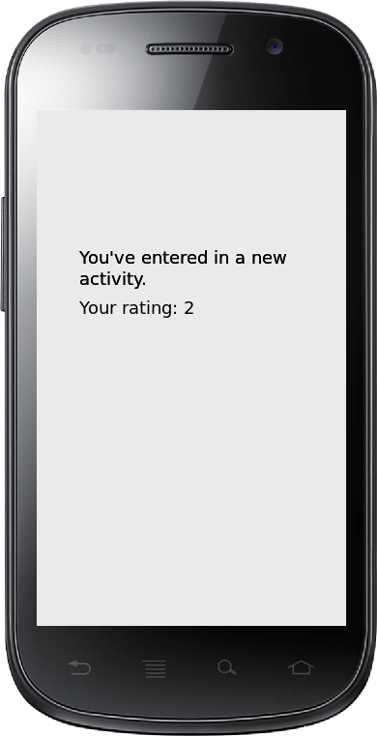
To experiment a bit with this application, you can download:

Block 9: SMS

The following application demonstrates the resort to a messaging app to send as an SMS a message composed in the application.
The application is represented on the left side phone. The right side phone represents the destination of the SMS. This application is composed of a single screen. The graphical interface proposes an editTex for the user to compose his message and a "Send" button:
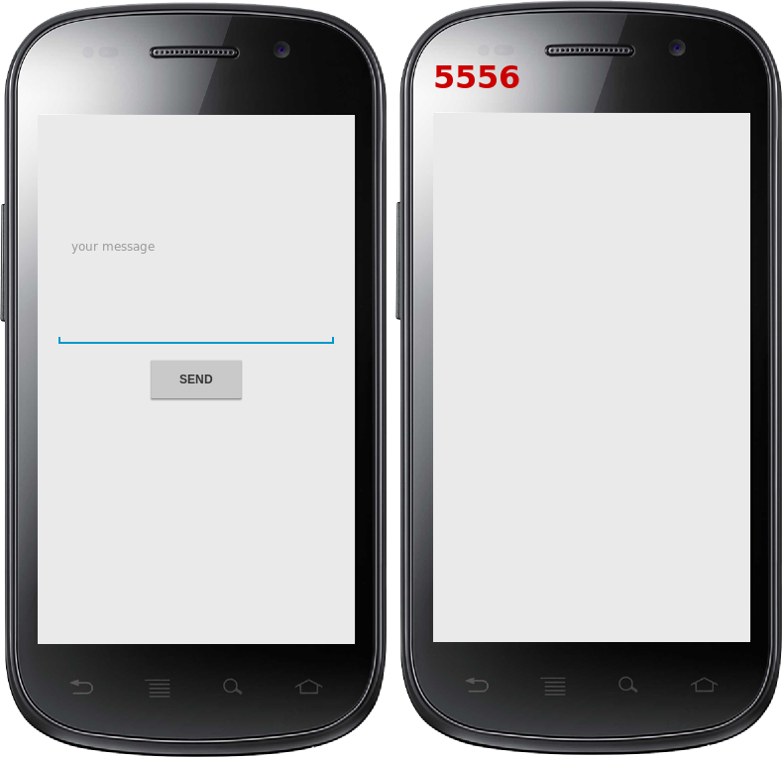
The user composes his message:
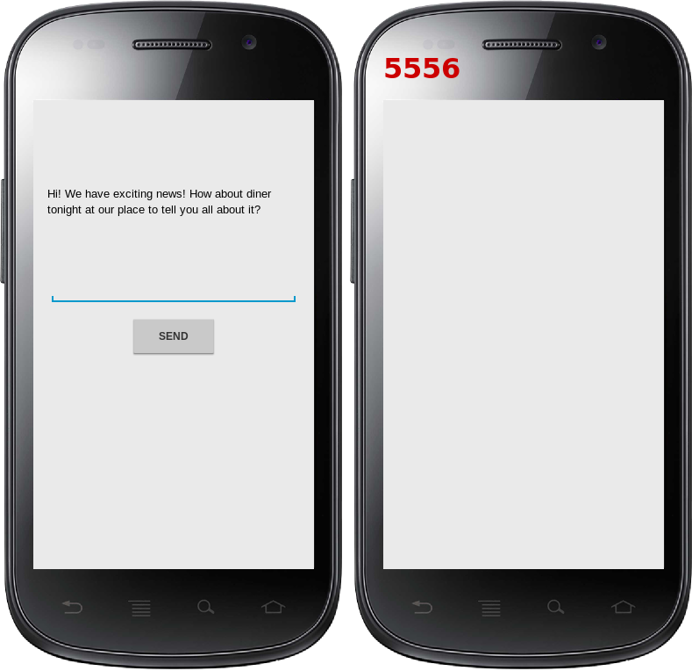
When the user clicks the Send button, one of the messaging app installed on the phone opens and a message with the text typed in by the user is ready to be sent to the destination (5556 in this example):
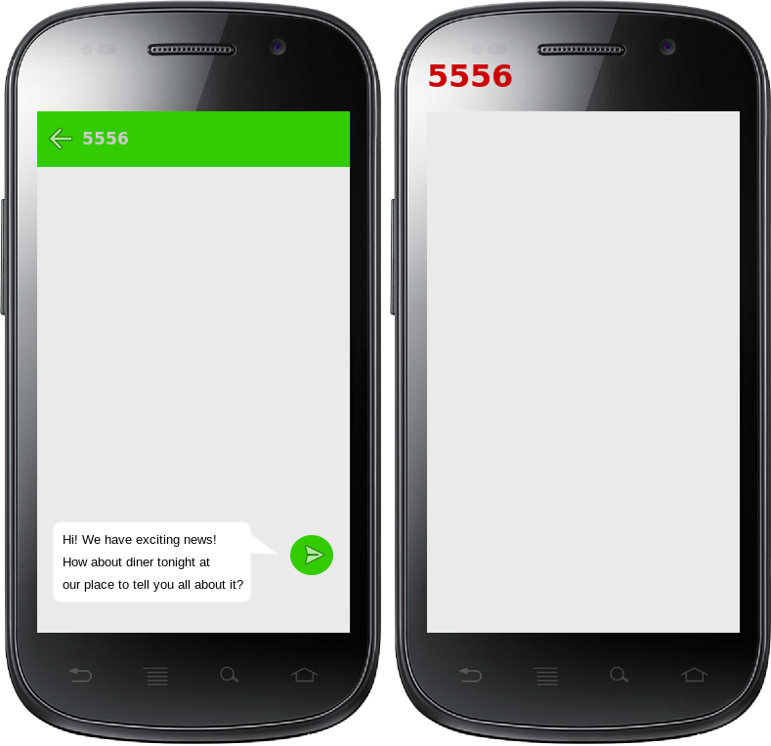
When the user clicks the Send symbol, the message is sent and the destination is notified of the new message arrival:
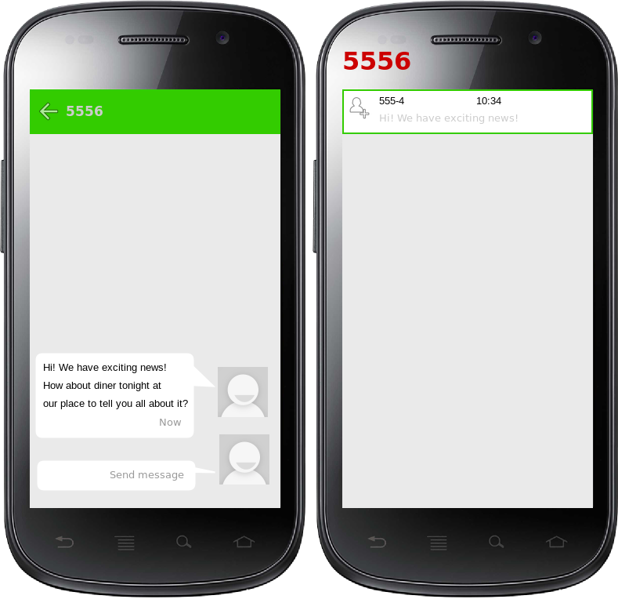
To experiment a bit with this application, you can download:
- the application to try it out on your phone:

